**Beginner Android Developer Task – To-Do List App (Kotlin + XML)**

This beginner Android development project focuses on building a **To-Do List application** that helps users keep track of their daily tasks. The app is developed in **Kotlin** using **XML layouts** (no Jetpack Compose) to provide hands-on experience with Android’s traditional UI system.

**Core Features:**

1. **Add Tasks** – Users can add a new task using an input dialog or text field.
2. **Mark as Completed/Uncompleted** – Tapping a task will toggle its completion status, visually distinguishing completed items (e.g., using strike-through text or a checkbox).
3. **Delete Tasks** – Users can remove tasks they no longer need with a delete button or swipe gesture.
4. **Persistent Storage** – All tasks are saved locally using **Room Database**, so the list remains intact even after the app is closed.
5. **Clean Material Design UI** – Uses **Constraint Layout** or **Linear Layout** for a simple and responsive interface, following Google’s Material Design guidelines.

**Technical Concepts Covered:**

* **Activities** for handling the main app screen.
* **Recycler View** for displaying the task list efficiently.
* **Adapters & View Holders** for connecting data to UI elements.
* **Room Database** for local data storage (Entity, DAO, and Database setup).
* **Live Data & View Model** for real-time UI updates and lifecycle-aware data handling.
* **MVVM Architecture** to separate business logic from UI code for better maintainability.

**Learning Outcomes:**  
By completing this project, beginners will:

* Understand the Android project structure and package organization.
* Learn how to bind Kotlin code with XML-based UI components.
* Gain experience with recycler View for dynamic lists.
* Practice database operations like **insert**, **update**, **delete**, and **query** using Room.
* Work with live Data to automatically refresh the UI when data changes.
* Get familiar with Material Design principles for a modern and user-friendly interface.

This project provides a solid foundation for building more advanced Android applications, making it an ideal first step for aspiring mobile app developers.

**Screenshot: Andriodmenifest.xml**

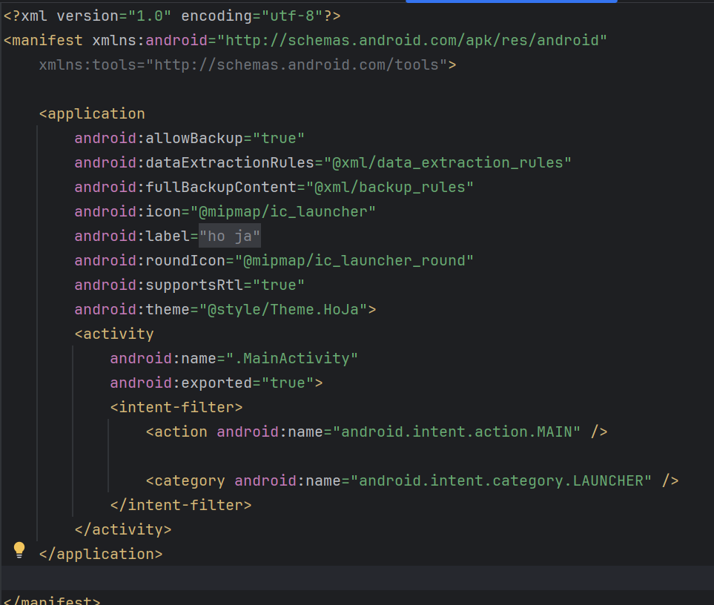

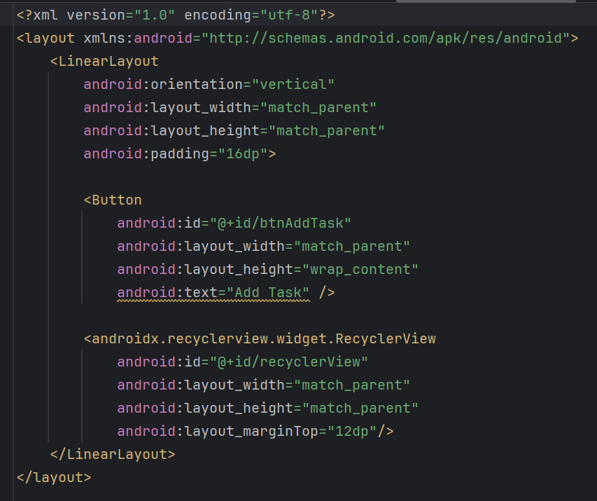**Main_activity.xml**

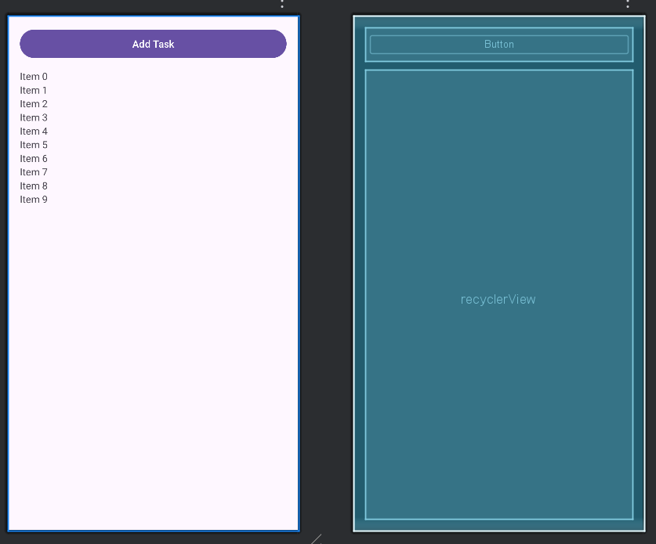

**dialog_item.xml**

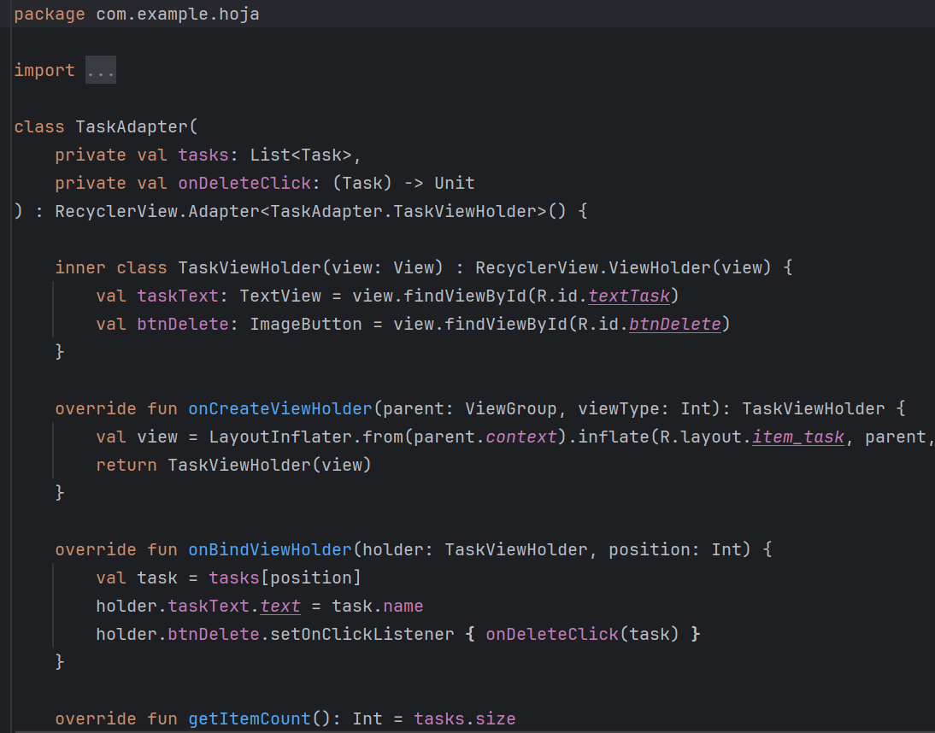**Taskadapter.kt**

**item_task.xml**

**Main Activity.kt**

